Static Library Generator

**[NEC Confidential]**

Revision: 1.0

Date: May 31, 2023

NEC Telecom Software Philippines, Inc.

# Revision History

|  |  |  |  |
| --- | --- | --- | --- |
| Revision | Updated by | Date | Description of changes |
| 0.01 | Elizar Jimenez | October 9, 2023 | Initial Draft Document |
|  |  |  |  |
|  |  |  |  |
|  |  |  |  |
|  |  |  |  |

# Related Documents

|  |  |  |
| --- | --- | --- |
| No. | Document Name | Description |
|  |  |  |
|  |  |  |
|  |  |  |

# Abbreviations

|  |  |
| --- | --- |
| Item | Description |
| CORS | Cross-Origin Resource Sharing |
| JSON | JavaScript Object Notation |
| HTTP | Hypertext Transfer Protocol |
| API | Application Programming Interface |
|  |  |
|  |  |
|  |  |
|  |  |
|  |  |

Table of Contents

Revision History 2

Related Documents 2

Abbreviations 2

1 Introduction 4

1.1 Purpose of this Document 4

1.2 Overview 4

1.2.1 Right Panel Features (Library Configuration) 4

1.2.2 Left Panel Features (File Management) 4

1.2.3 Middle Panel Features (Function Selection) 5

1.2.4 Modal Features (Summary and Confirmation) 5

2 Design 6

2.1 Frontend Design Overview 6

2.2 Backend Design Overview 7

3 Tool Operation 8

3.1 Frontend (React) and Backend (Flask) 8

3.2 Procedures 9

3.2.1 Adding a C file to the Left Pane 9

3.2.2 Adding extracted functions to the Right Panel 9

3.2.3 Adding all extracted functions to the Right Panel 9

3.2.4 Configuring the Right panel for the Library Creation 9

3.2.5 Downloading the Library 10

3.2.6 Display Summary of the Library (Modal) 10

4 Appendix 11

4.1 Sample Output 11

# Introduction

## Purpose of this Document

The purpose of this document is to give an overview of the static library generator tool its application, design, environment and its features and product offer. It serves as manual and a guide for users who interact with the web application. Provide information on how users, whether developers or end-users, can navigate through and understand the functionalities of the application.

Understanding the architecture, design choices, and operation of the web application's components. Serves as a resource for troubleshooting common issues and errors that users might encounter. Provide a shared understanding of the application's structure, functionalities, and workflows.

## Overview

The Static Library Generator Tool is a user-friendly web application designed to facilitate the creation of custom and dynamic libraries. The tool is divided into three main panels: Right, Left, and Middle, each serving a distinct purpose in the library generation process. The tool is developed using ReactJS (Frontend) and Python Flask (Backend) it is intended to be launched in Linux environment.

### Right Panel Features (Library Configuration)

The Right Panel is capable of the following features:

* Input Name of the Library: Users must provide a unique name for the library.
* Input Dummy Function: Specify the dummy function to be included in the library.
* Select Library Type: Choose between a Static (.a) or Shared (.so) library.
* Add/Remove Input Fields: Dynamically add or remove input fields and functions as needed.
* Download Generated Library: Users can download the generated library once configured.
* Create Button: Initiates the library generation process and opens a modal/summary.
* Display Library Name: The tool displays the library name with the appropriate file extension based on the library type.
* Edit Input Fields/Functions: Allow users to edit input fields and functions as required.
* Alerts: Users are alerted if functions don't follow the specified format/regex, if the library name is empty, or if there are no input fields.

### Left Panel Features (File Management)

The Left Panel is capable of the following features:

* Browse Files and Functions: Users can explore and select files and functions from their device.
* Search Box: Highlights terms matching the user's input in the search box.
* Save/Remove C Files: Enables saving and removing C files in the browser.
* Extract Functions: Automatically extracts functions from selected C files.
* Display Extracted Functions: Shows the extracted functions of C files in the library.

### **Middle Panel Features (Function Selection)**

The Middle Panel is capable of the following features:

* Add Button: Adds the selected functions from the left panel to the right panel.
* Add All Button: Adds all functions from the left panel to the right panel.
* Alerts: Users are alerted if no functions are selected.

### Modal Features (Summary and Confirmation)

The Modal is capable of the following features:

* Display Information: Presents library name, library type, and functions to be generated.
* Cancel Button: Allows users to abort/close the library creation process.
* Confirm Button: Enables users to confirm and proceed with library generation.

# Design

## Frontend Design Overview



Figure 1: *Main page Design*



Figure 2: *Modal page Design*

## Backend Design Overview

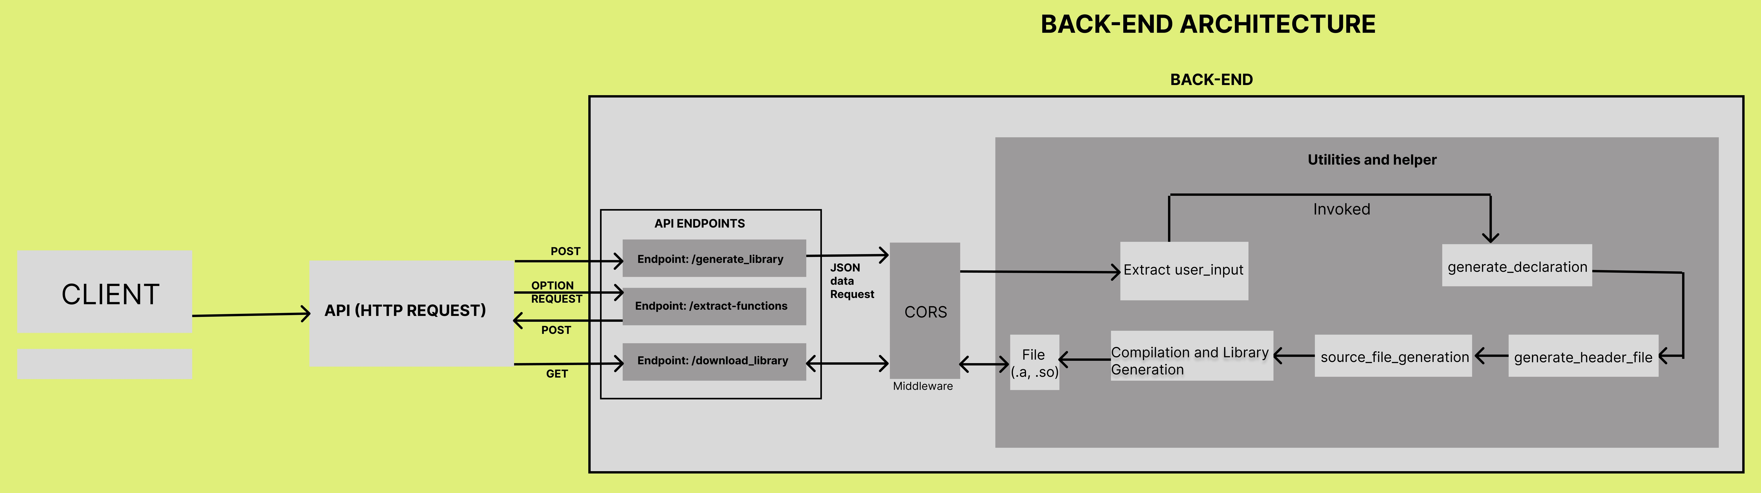

Figure 3: *Backend Architecture Design*

Client (Web Browser):

* Initiates interactions by making HTTP requests.

Flask Application:

* Serves as the backend.
* Defines routes and views to handle requests.
* Interacts with library generation logic.

Routes and Views:

* Define URL patterns and corresponding Python functions.
* Handle logic for generating libraries and downloading files.

Type Declaration Generator:

* Generates type declarations and function declarations based on user inputs.
* Parses input and generates C source code.

Library Generation Logic:

* Takes user inputs, generates C source code, and compiles it into a library.
* Interacts with the Type Declaration Generator.

External APIs and Libraries:

* May interact with external components for specific purposes (not shown).

File System:

* Temporarily stores generated library files, c files, etc.

Configuration (config.py):

* Stores configuration settings for the application.

Data Flow and Interaction:

* Client Request:
* Initiates a request by accessing specific URLs.
* Requests are routed to appropriate view functions.

Library Generation:

* Type Declaration Generator creates C source code.
* Library Generation Logic compiles sources into a library.
* Temporary library file stored on the server.

Download Request:

* User requests to download the library.
* Flask sends the library file as an HTTP response.

Cleanup:

* After successful download, server deletes the temporary library file.

# Tool Operation

## Frontend (React) and Backend (Flask)

**Frontend (React):**

User Interactions:

* Enter library name, select library type, add function inputs, C files.
* Trigger frontend events and state changes.
* Click the “Create" button to initiate library creation.

State Management:

* Utilizes React hooks like useState, useEffect, and useRef.

**Backend (Flask):**

Library Generation Process:

* Receives POST request in the /generate_library route.
* Extracts library name, type, and function inputs.
* Generates C/C++ type declarations and a header file.
* Compiles declarations and sources into a library (static/shared) using GCC.
* Returns error message if any issues arise.

## Procedures

### Adding a C file to the Left Pane

To add c file to the left pane, do the following instructions:

1. Users click the “Open File” button beside the search bar.
2. A file explorer will prompt the screen.
3. Locate and click the selected c source file.
4. Click “Open” button to add the file in the Left pane.
5. Click the “C files” Tab in the left pane.
6. Check if the file appears.

Refer to Figure 4.0.1 in 4.1. Sample Output for the visual guided procedure.

**Note:** If the file is not shown please refresh the page and try again until it is shown in the “C Files” tab.

### Adding extracted functions to the Right Panel

If the C file is saved in the “C Files” tab, it will display the extracted functions in the “Library” tab. To add extracted functions to the right panel, do the following instruction:

1. Go to the “Library” tab in the left pane.
2. Click the checkbox/s, if you select that specific function/s to be added in the right pane.
3. Click the “ADD” button in the middle of the right and left pane.
4. Check if the selected function/s are in the right pane.

Refer to Figure 4.0.2 in 4.1. Sample Output for the visual guided procedure.

### **Adding all extracted functions to the Right Panel**

If the C file is saved in the “C Files” tab, it will display the extracted functions in the “Library” tab. To add all extracted functions to the right panel, do the following instruction:

1. Go to the “Library” tab in the left pane.
2. Click the “ADD ALL” button in the middle of the right and left pane.
3. Check if the selected function/s are in the right pane.

Refer to Figure 4.0.3 in 4.1. Sample Output for the visual guided procedure.

### Configuring the Right panel for the Library Creation

To configure the right panel, do the following instructions:

1. Add the library name in the right pane (REQUIRED).
2. Select the library type.

**Note**: The default library type is “Static”. Check the library type.

1. Add the function/s.
   1. If user wants to add the function/s from the left pane, please refer above.
   2. If the user wants to add the function dynamically, refer to number 4.
2. Add new input field, Click the **“+”** button.
3. Click the new input field to add the function.

**Note:** Follow the format in creating the function, e.g., “int functionName (<parameters>):”. Additional modifier is also accepted. Also, you cannot add a new input field if there is an empty input field.

1. “Remove” Button removes the input field.

**Note:** If the user clicks or selects specific input fields then clicks the “Remove” Button it will delete that specific input field, but if the user does not click any input field, then clicks the “Remove” button it will delete the last input field.

1. Click the “Create” button if above is satisfied. It will open the modal.

Refer to Figure 4.0.4 in 4.1. Sample Output for the visual guided procedure.

**Note:** Clicking the “Download” Button will just alert user if that the “Library is not ready for download”. Clicking the input field or the function will allow the user to delete or edit it. Duplicate functions are not allowed.

### Downloading the Library

To download the library, do the following instructions:

1. User clicks "Download" button.

* Sends GET request to /download_library route with library name and type.

1. Locates and sends the library file back to the frontend for download.

**Note:** If the download button is still disable after the configuring and confirming the library creation/generation, there something wrong in the compilation of the function, please check the functions and the syntax that might conflict with the generation of the library.

### Display Summary of the Library (Modal)

Display a summary of the library to be created.

* Appears when the user clicks "Create" button.
* Shows library name, type, and function inputs.
* Users can confirm or cancel library creation through the modal.

**3.2: Web Application Backend Architecture**

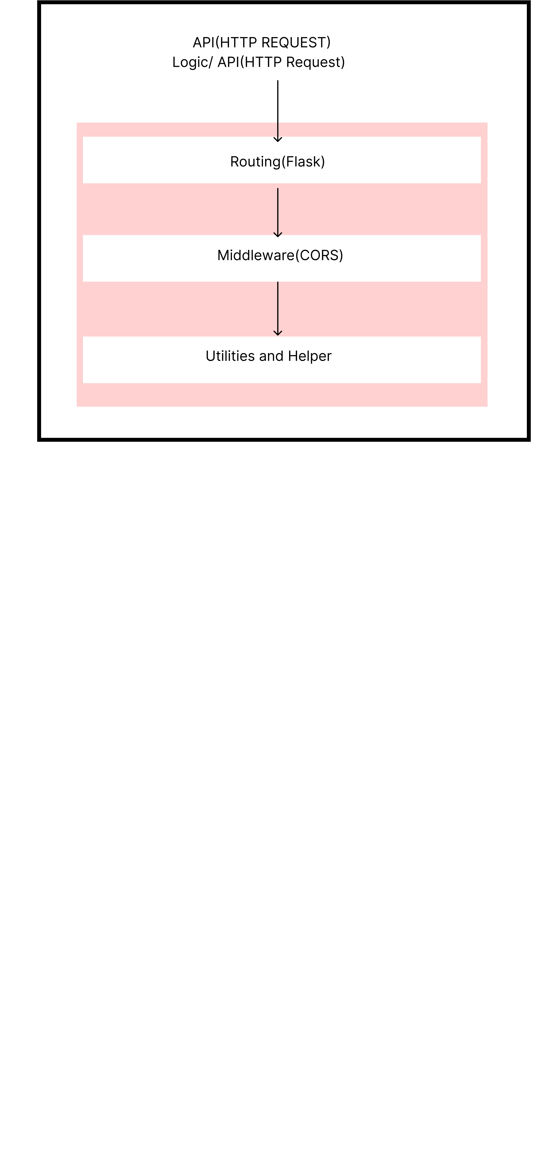

Figure 3.1: *Backend Architecture Design*

# Appendix

## Sample Output

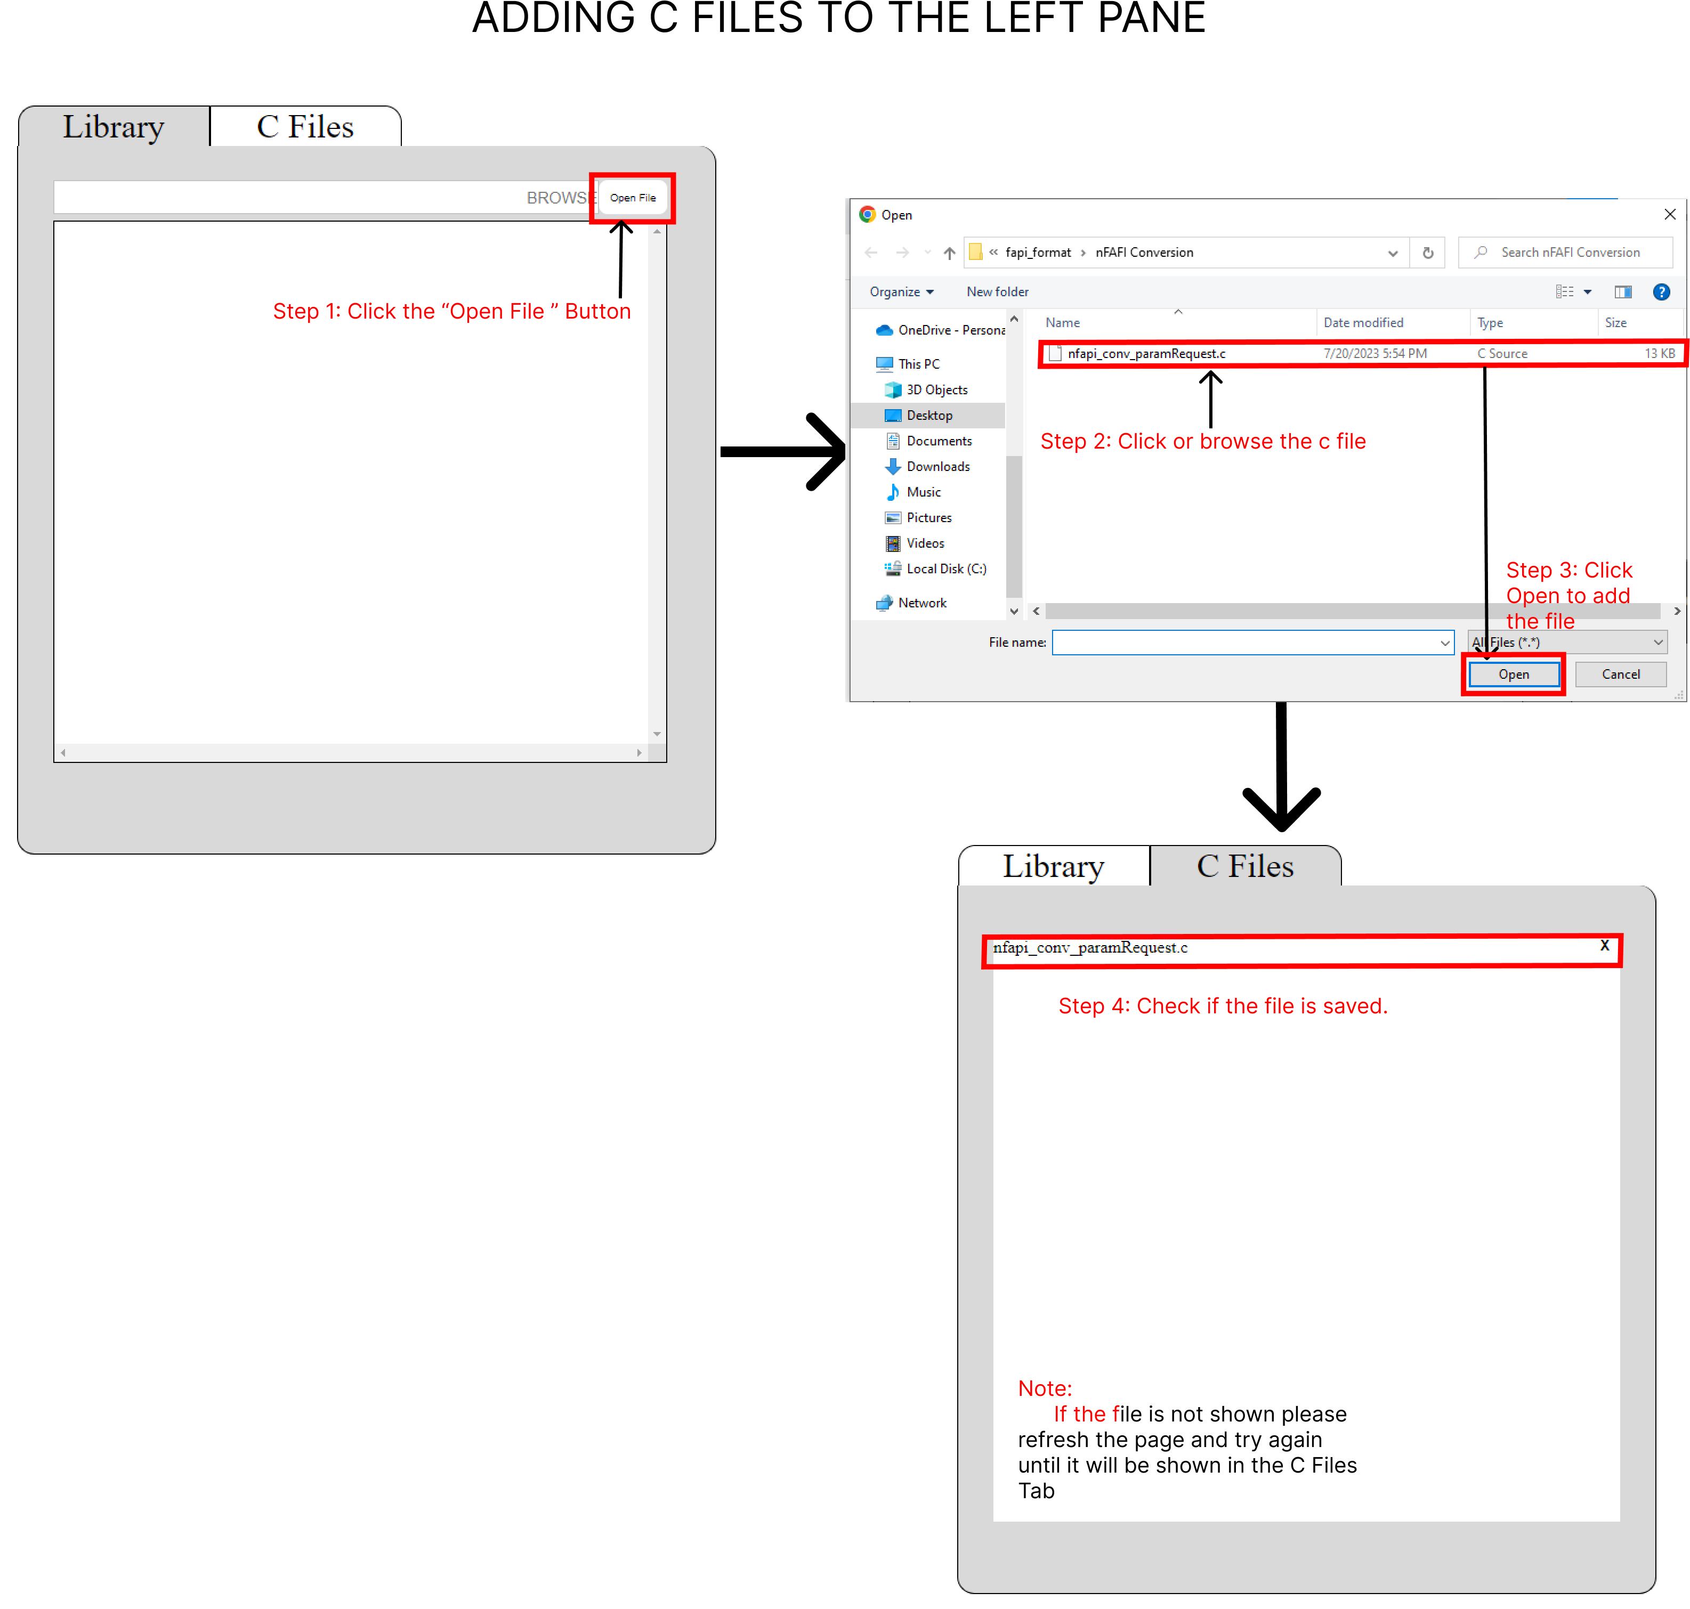

Figure 4.0.1: *Adding C Files to the left panel.*

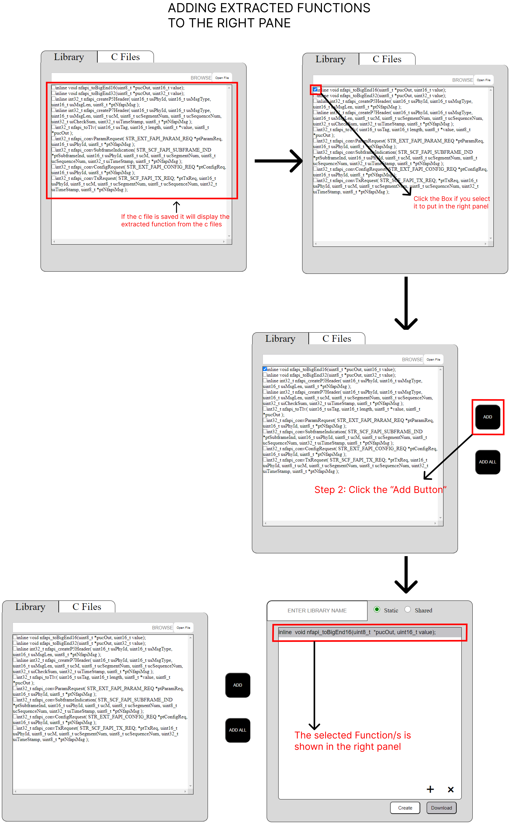

*Figure 4.0.2: Adding Extracted Functions to the right panel.*

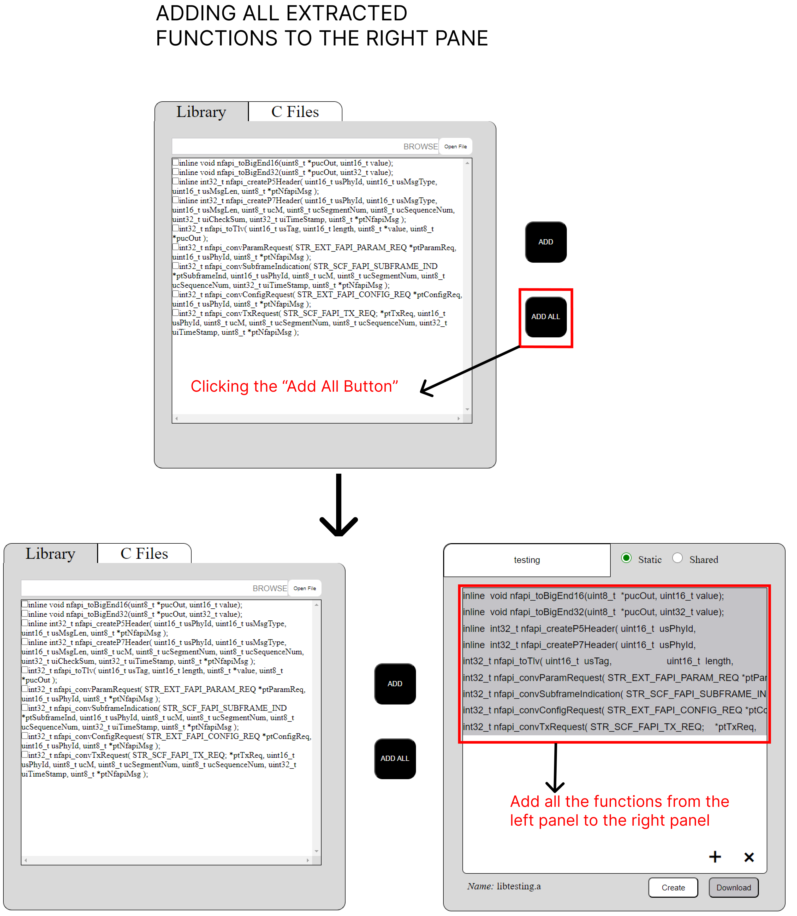

*Figure 4.0.3: Adding All Extracted Functions to the right panel.*

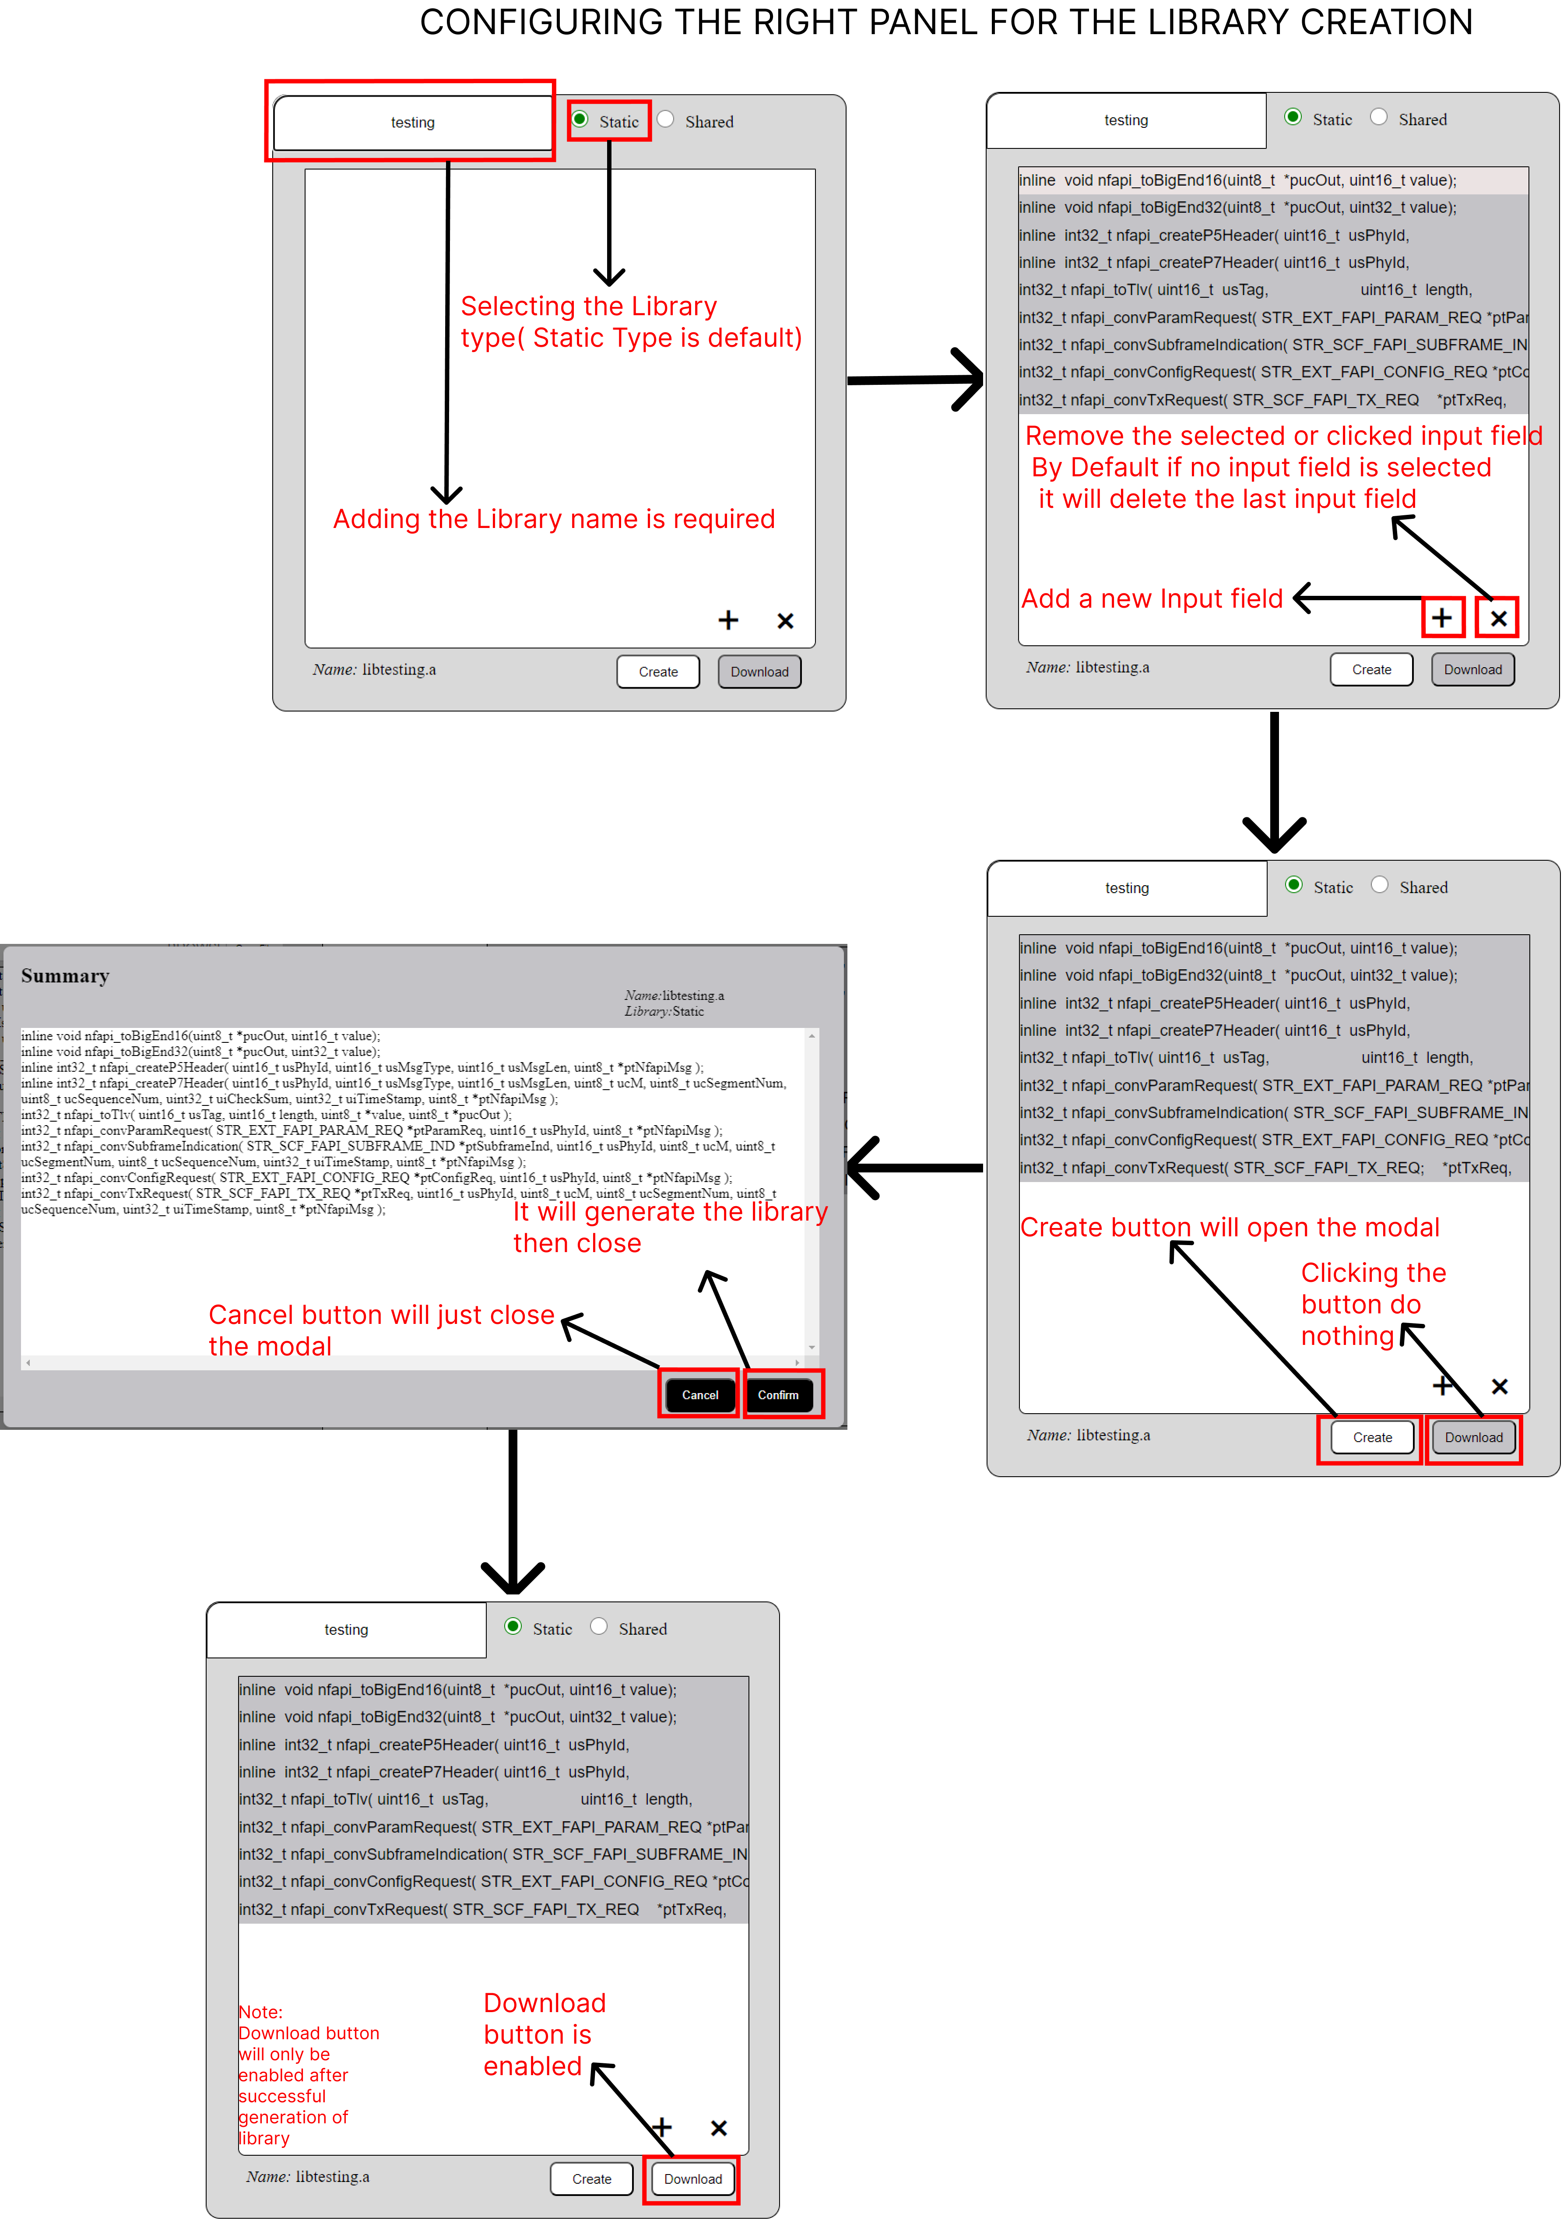

*Figure 4.0.4: CONFIGURING THE RIGHT PANEL FOR THE LIBRARY CREATION*